
Master of Music Recital

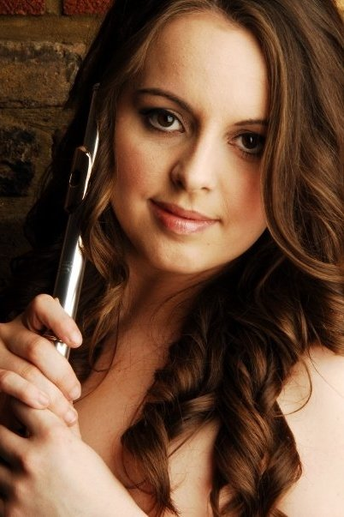
Abigail Wilkinson, Flute
Paul Gardner, Piano

Turner Sims Concert Hall
Monday 31st January 2011
1pm

Programme

Concierto Pastoral Joaquin Rodrigo (1901-1999)
II Adagio

Sonata in E Major BWV 1035 J.S Bach (1685-1750)
Adagio ma non tanto
Allegro
Siciliano
Allegro assai

Spiral Lament Ian Clarke (b.1964)

In Ireland, Fantasy Hamilton Harty (1879-1941)

Concierto Pastoral

Perhaps best known for his Concierto de Aranjuez for guitar and orchestra, Joaquin Rodrigo wrote many concertos for different instruments including Concierto Pastoral, his only concerto for flute. It was composed in 1978, commissioned by the internationally renowned flautist, James Galway, who premiered the concerto in the Royal Festival Hall in London on October 17th 1978 with the Philharmonia Orchestra conducted by Eduardo Mata. Rodrigo dedicated this concerto to James Galway, whose recording of the complete work is regarded as one of the most expressive and technically brilliant.
The second movement, Adagio, is the source for the name Pastoral in this concerto’s title which, true to Rodrigo’s unique style of writing, features many typical Spanish-style runs and flourishes for the flute which could almost be described as bird-like. Surrounding these are moments of beautiful lyricism and calm that conjure images from nature.

Sonata in E Major BWV 1035
Johann Sebastian Bach (1685-1750) came towards the end of a long line of musical Bachs from a period spanning almost two hundred years. The tradition came to an end after the death of his sons; Carl Phillip Emmanuel, Johann Christian, Johann Gottfried Bernard, Wilhelm Friedemann and Johann Christoph Friedrich. J.S. Bach remains the most famous and widely respected Bach and is regarded as one of the main composers of the Baroque style. Some of his most famous works include the Brandenburg Concertos, Toccata and Fugue in D Minor and St John Passion.
During the summer of 1741, J.S Bach travelled to Berlin where he encountered the chamberlain to King Frederick the Great, Michael Gabriel Fredersdorf, who was, like the King, an accomplished flautist. An early manuscript copy of the E Major Sonata seems to indicate that J.S. Bach wrote the work for the chamberlain during the course of his visit.

Spiral Lament
Ian Clarke is acknowledged as one of the leading player/composers in the flute world. His compositions have been performed across five continents on stages ranging from London’s South Bank to the Glastonbury Festival and have been featured in the last four BBC Young Musician Woodwind Finals. IC Music Publishers state that “Ian’s music is some of the most exciting repertoire of today!”
Spiral Lament was one of Ian Clarke’s more unusual commissions that came about when Hannah Money asked him to compose a piece about her giant African snails. After initially being somewhat perplexed by this request, Ian then went to meet one of these snails and described it as “an unforgettable moment!” He gazed in wonder at the creatures, likening the experience to looking through a window into a “strange and wondrous alien world.” The winding, hypnotic phrases in this piece represent the pattern of the snail’s shell and its general slow and tranquil nature.

In Ireland

Irish-born Sir Herbert Hamilton Harty’s work, whilst being classically disciplined, largely draws upon Irish folk music which Harty was exposed to during his childhood days in Down and his time in Dublin, Ireland. During his lifetime he became known for his skills, not just as a composer, but as a conductor. He conducted several orchestras over the years, most notably The Halle and The London Symphony Orchestra. Harty’s health deteriorated in 1936 quite dramatically, though he continued to compose even after having a malignant brain tumour and his right eye removed. His ashes were placed in his hometown, Hillsborough in Ireland at the Parish Church where his father, William Michael Harty (1852-1918), was once the church organist.
Composed in 1918 for flute and piano, the fantasy In Ireland was later arranged for flute and orchestra. It is a programmatic fantasy which clearly draws upon Harty’s own experiences of Dublin during the time he spent living there. The score reads:
In a Dublin street at dusk, two wandering street musicians are playing.

Biographies
Abigail Wilkinson, flute
Abigail graduated in July 2010 with a BA honours degree in Music at the University of Southampton. She is currently co-directing Music and Dance which will take place in the Turner Sims Concert Hall on Monday May 9th 2011 at 1pm. The concert will feature some of Southampton University’s finest musicians, the highly regarded Ballroom and Latin Society and special guests The Jane Austen Dancers. For more information please visit the website at musicanddancemaynine.wordpress.com.
As an undergraduate, Abigail performed regularly with The Southampton University Symphony Orchestra and Southampton University Sinfonietta as well as several production groups such as Showstoppers and the Light Operatic Society as an orchestral musician. During her time at Southampton she also formed part of a classical flute and guitar duo “Off the Scale” with fellow undergraduate, John Breese.
Over the years, Abigail has performed in several orchestras as principal flautist such as The National Youth Wind Orchestra, The South West Youth Orchestra, The National Youth Chamber Orchestra, The Dorset Youth Orchestra, The Wessex Youth Orchestra and The Bournemouth Festival Orchestra. Abigail has toured in various countries including France, Belgium, Colombia and in the U.K both as an orchestral musician and as a soloist. Her orchestral experience has brought her into contact with many prestigious conductors such as Marin Alsop, Greg Beardstall, Mark Forkel and the late Don Riddell MBE. Her most notable performance was leading a wind quartet in “The Unanswered Question” by Charles Ives in The Royal Albert Hall.
Prior to commencing study at The University of Southampton, Abigail studied under the innovative and internationally acclaimed flautist and composer, Ian Clarke. During her time as a pupil of Ian Clarke, Abigail obtained both her Associate and Licentiate diplomas in flute music performance, gaining Distinctions in both. Abigail has also studied under a formal principal flautist of the London Symphony Orchestra, Nicholas Vallis-Davies. She has also attended masterclasses with artists such as Clare Southworth, Michael Cox and Paul Edmund-Davies. Here at Southampton she has been tutored for the past three years by Katy Bircher, a specialist in early flute music who tours regularly in the UK and abroad as a solo artist and as part of various Baroque ensembles.
Paul Gardiner, piano

Paul Gardner started learning the piano from an early age, having been introduced to the instrument by a friend of the family. In 1991 he and his brother Michael won a national piano competition, sponsored by Yamaha, playing a series of duets. The following year he gained a distinction for his Grade 8 piano exam, and has since gained both Honours and Masters Degree qualifications in Music from Southampton University.

Paul mainly plays as an accompanist, and enjoys regularly accompanying students at the University of Southampton in concerts and their final recitals. He has also played a number of concertos with various local orchestras, including Rachmaninov’s Rhapsody on a Theme of Paganini with the Southampton University Symphony Orchestra, as well as concertos by Ravel, Schumann, Shostakovich and Rachmaninov's 1st. He has also recently created a new web-based business where students can download accompaniment tracks to classical instrumental repertoire.

